

Minor Project Report

On

Library Management System

**SUBMITTED TO:**  **SUBMITTED BY:**

Name-Prof. Syamala Devi Name: Raman Kumar

Panjab University Roll Number: 34

MCA-Batch 2021-24

**DECLARATION**

I Raman Kumar student of MCA 1 semester, batch 2021-24 declare that this project has been finalized by me. This project is an original piece of work and not copied from any other sources. This project report is being submitted in partial fulfilment of the degree of Master of Computer Application from Panjab University and has not been submitted for the reward of any certificate, diploma, degree, fellowship with any other college, university, or educational institute before this. In case any part of this is reported as copied from any other source, I shall be solely responsible for the same and will be answerable for any action in this regard.

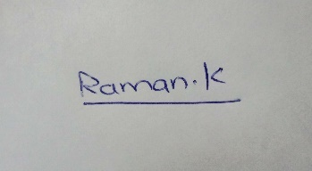

…………….……………..

Student’s signature

Name: Raman Kumar

Roll Number:34

**ACKNOWLEDGEMENT**

The satisfaction that accompanies that the successful completion of any task would be incomplete without the mention of people whose ceaseless cooperation made it possible, whose constant guidance and encouragement crown all the efforts with success. I am grateful to our project guide **Mrs. Syamala** Mam for the guidance, inspiration, and constructive suggestions that help in the preparation of this project. I am also thankful to my friends who have helped me in the successful completion of the project.

**Abstract**

Library Management System is a system that maintains the information about the books. This is very difficult to organize manually. Maintenance of all this information manually is a very complex task. Owing to the advancement of technology, the organization of a Library becomes much simple. The Library Management has been designed to computerize and automate the operations performed over the book like adding new books, searching books, displaying books that are presented in the library, and many other operations also. This computerization of the library helps in many instances of its maintenances. It reduces the workload of management as most of the manual work done is reduced.

Contents

***TOPICS Page Number***

**1. INTRODUCTION 6**

1.1 NEED and OBJECTIVE 6

**2. Project Design 7-14**

2.1 Flowchart 7

2.2 Feature of project 8

2.3 Database Design 14

**3. Implementation 15-42**

3.1 Hardware and software specification 15

3.2 Project Details 15

3.3 Project Code 16

3.3.1 Header File and function 16

3.3.2 Welcome Page 17

3.3.3 Login Page 18

3.3.4 Main Menu 21

3.3.5 Add Books 24

3.3.6 Display Books 26

3.3.7 Search Book 28

3.3.8 List all Books by Title 33

3.3.9 Total Number of Books 34

3.3.10 Delete Book 36

3.3.11 Exit or Welcome Page 41

**4. Testing 43-45**

**5. Conclusion 46**

5.1 Future Scope 46

**6. References 47**

Introduction

A college library management is a project that manages and stores books information electronically according to Librarian needs. The system helps both students and library managers to keep a constant track of all the books available in the library. It allows both the admin and the student to search for the desired book. This task if carried out manually will be tedious and includes chances of mistakes. Thus, this system reduces manual work to a great extent allows smooth flow of library activities by removing chances of errors in the details.

* 1. Need and Objective of Project

A Library management system is software that uses to maintain the record of the library. It contains work like the number of available books in the library. Library Management Systems is software that helps to maintain a database that is useful to enter new books &search books. Moreover, it also reduces the manual record burden of the librarian. A library management system allows the librarian to maintain library resources in a more operative manner that will help to save time. A library management system is also useful for students as well as a librarian to keep constant track of the availability of all books in a store.

2.Project Design

2.1 Flowchart-

Display Books

Delete Book

Main Menu

Add Book

Search Book

Total Book

By id

By book name namename

Login

WELCOME   
SCREEN

3 times Wrong Id or Password is entered

List By Title

Exit

By Id

Conformation

End Screen

2.2 Feature of Project

Add Books

Display Books

Login

List by Title

Number of Books

Delete Book

Search Book

Feature of C Used in this Project

Loops

Arrays

Functions

Control Statement

String

Structure

Files Handling

C by Dennis Ritchie

* Control Statements: Control statements like if else statements, switch statements and loop statements are used in this project.
* Functions: Different types of functions are defined or called throughout this project. There are two types of functions user-defined and standard library function.
* *Standard Library Function*: These are those functions that are predefined functions in the library.

Example: printf(), scanf(), gets(), main(), etc.

* *User-Defined Function*: These are Functions that are defined by the program coder. Example:

1. addbooks(): This function is used to add books to the library.
2. displaybooks(): This function is used to view all the books that are present in the library.
3. searchbook() : This function is used to search books in the library. In this function two more functions are defined which can help us to search in an efficient way searchbyid() and searchbybookname().
4. listbooks(): This function is used to list books in the library in a title-wise manner. This function helps the user to show all books available with the title.
5. totalbooks(): This function is used to tell us how many books are present in the library.
6. deletebooks(): This function is used to delete books from the library.
7. mainmenu(): This function is used to display all other functions.

* Arrays: It is a collection of similar types of data items stored at the contiguous memory location. In this project, a character array is used to store the author’s name and book name.
* Structure: In this project library type struct is used. Book is variable of datatype library which is created by using the struct keyword. In this int type id, string type book name and author name are defined.

Example: struct library

{

int bk_id;

char bk_name[30];

char author[30];

int pages;

float price;

} li;

* File Handling: Different types of file handling functions are used like to open file fopen() is used. To read and write into file fwrite() and fread() function are used. There is a different type of mode to open a file like a, a+, w, w+, r, r+. To store data two external files are used. From those two one is used to delete records from the library.
* Header Files- Different Header files are used like conio.h, stdio.h ,string.h ,stdlib.h ,window.h.

#include <conio.h>: This header file stands for console input and output. Used to perform a function like screen getch();, etc.

#include <stdio.h>: This header file stdio.h stands for standard input output. Functins like printf(), scanf(),etc are included in this library file.

#include <string.h>: This header file is used to perform string function.

Example- strcat(), strlen(), strcmp() etc.

#include<stdlib.h>: It’s stands for standard library. exit() function used in project is defined in this library.

Error Controls in the project:

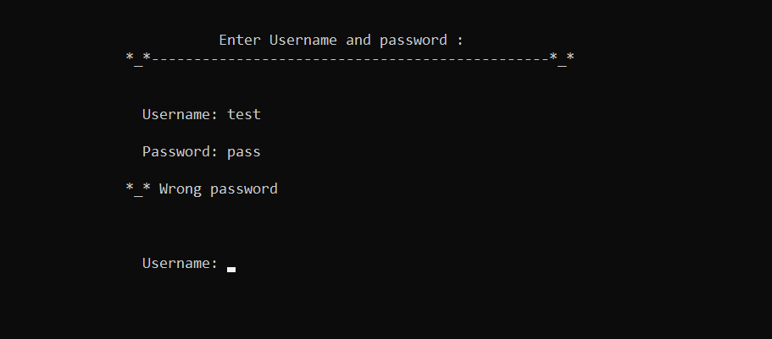

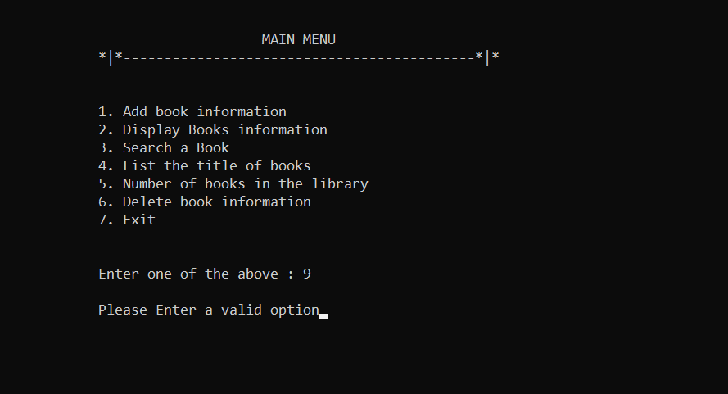

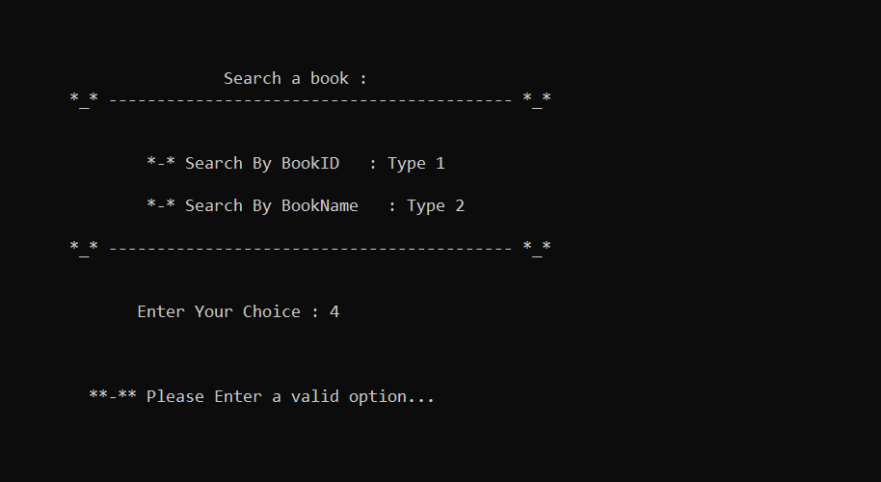

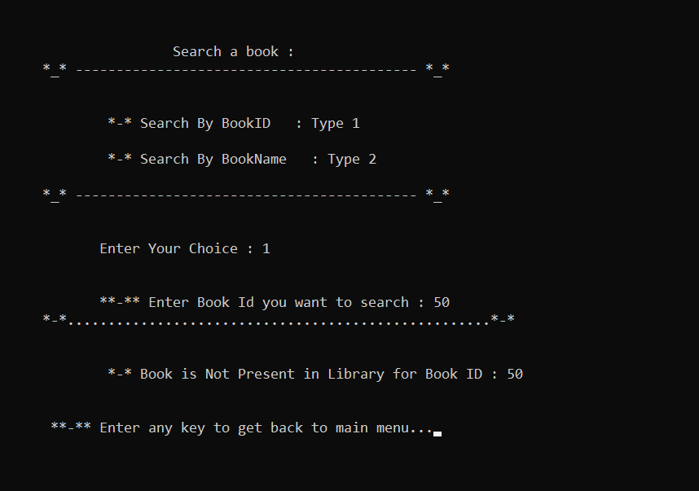

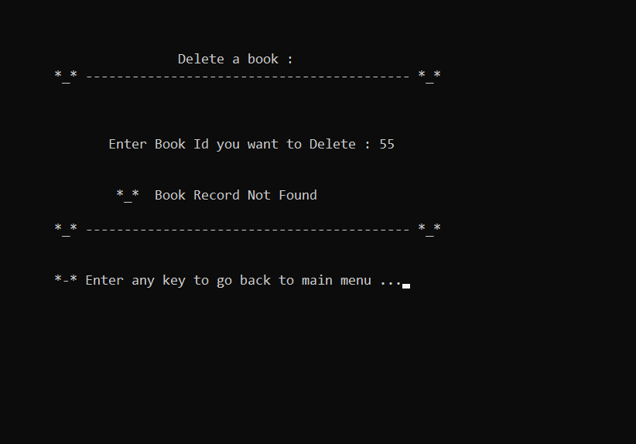

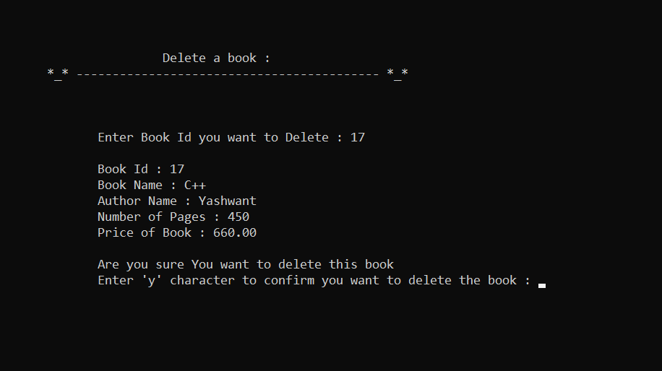

2.3 Database Design:

file1.txt

Book Detail

bk_id int

bk_name str

author str

pages int

price float

Add Books

bk_id int

bk_name str

author str pages int

price float

Display Books

bk_id int

bk_name str

author str

pages int

price float

Delete Book

bk_id int

Search Book

bk_id int

bk_name str

3.Implementation

3.1 Hardware and Software Specification-

a. 4 GB RAM

b. 1TB Hard disk

c. Microsoft Windows 10

d. Intel Core i5

e. Dev C++

f. Virtual Studio Code

3.2 Project Details

The Project file name is “library management system”. Name of the C file and executable file is “library_management_system.c” and “library_management_system.exe”. To store data there is a temporary file name” myfile1.txt”. The user id and Password of the login page are **“test” and “pswd”** respectively.

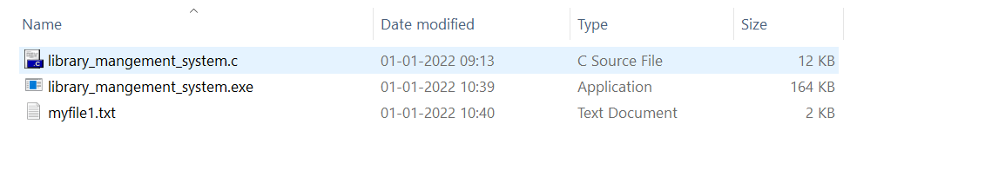

3.3 Project Code

1. **Header File and Function:**

// User Id: test

// Passwrod: pswd

#include <stdio.h>

#include <conio.h>

#include <stdlib.h>

#include <string.h>

void welcome_msg(void); // Declaration of Welcome Screen

void username_pass(void); // Declaration of Login screen

void mainmenu(void); // Declartion for main menu screen

void addbooks(void); //addbooks function declaration

void displaybooks(void); //displaybooks function declaration

void searchbook(void); //searchbooks function declaration

void listbooks(void); //listbooks function declaration

void totalbooks(void); //totalbooks function declaration

void deletebooks(void); //deletebooks function declaration

void endscreen(void); //endscreen function declaration

struct library

{

int bk_id;

char bk_name[30];

char author[30];

int pages;

float price;

} li; //Global declaration can be used from anywhere in the program

FILE *f1, *fr, *fd; //Global declaration of files used.

**2.Welcome Page (welcome_msg()):**

// WELCOME SCREEN

void welcome_msg(void)

{

char c;

printf("\n\n\n\n\n");

printf("\n\t\t\t\t **-**-**-**-**-**-**-**-**-**-**-**-**-**-**-**-**-**-**\n");

printf("\n\t\t\t\t =-=-=-=-=-=-=-=-=-=-=-=-=-=-=-=-=-=-=-=-=-=-=");

printf("\n\t\t\t\t = WELCOME =");

printf("\n\t\t\t\t = TO =");

printf("\n\t\t\t\t = LIBRARY =");

printf("\n\t\t\t\t = MANAGEMENT =");

printf("\n\t\t\t\t = SYSTEM =");

printf("\n\t\t\t\t =-=-=-=-=-=-=-=-=-=-=-=-=-=-=-=-=-=-=-=-=-=-=\n");

printf("\n\t\t\t\t ..........................................................\n");

printf("\n\n\n\t\t\t Enter any key to continue.....");

getch();

}

OUTPUT:

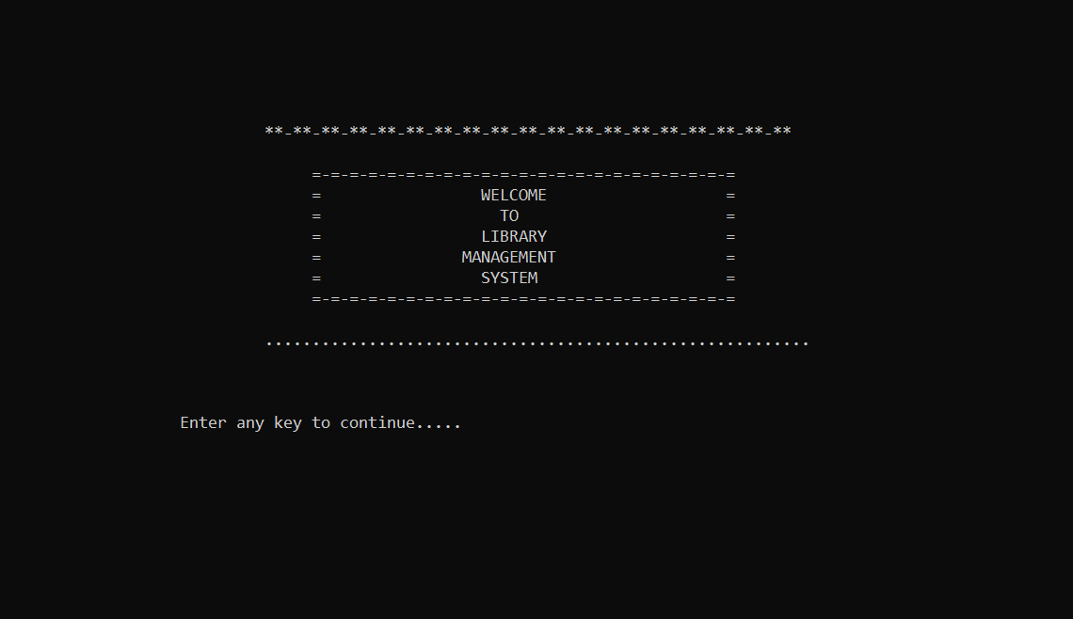

Welcome Page

**3.Login Page (username_pass()):**

/* login using id and pass */

void username_pass(void)

{

system("cls"); // Used to clear the screen

char str[] = "test";

char pwd[] = "pswd";

char str2[20];

char pwd2[20];

int i = 0;

printf("\n\n\t\t\t Enter Username and password : ");

printf("\n\t\t*_*-----------------------------------------------*_*");

while (i < 3)

{

printf("\n\n\n\t\t Username: ");

gets(str2);

printf("\n\t\t Password: ");

gets(pwd2);

if (strcmp(str, str2) == 0)

{

if (strcmp(pwd, pwd2) == 0)

{

printf("\n\n\t\t Press any key to continue...");

getch();

mainmenu();

}

else

{

printf("\n\t\t*_* Wrong password\n");

i++;

}

}

else

{

printf("\n\t\t*_* Wrong username\n");

i++;

}

}

if (i == 3)

{

printf("\n\n\t\t**-** -- Too many wrong attempts -- **-** ");

getch();

exit(0);

}

}

OUTPUT:

Login Page

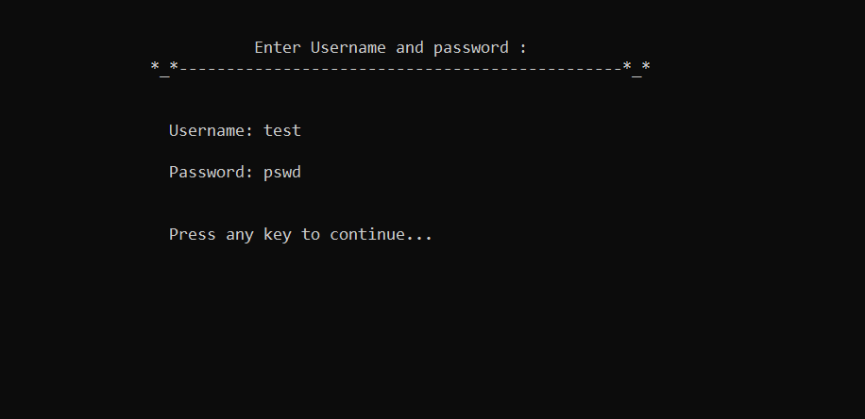

If the Password or User Id is incorrect more than 3 times it will exit the program.

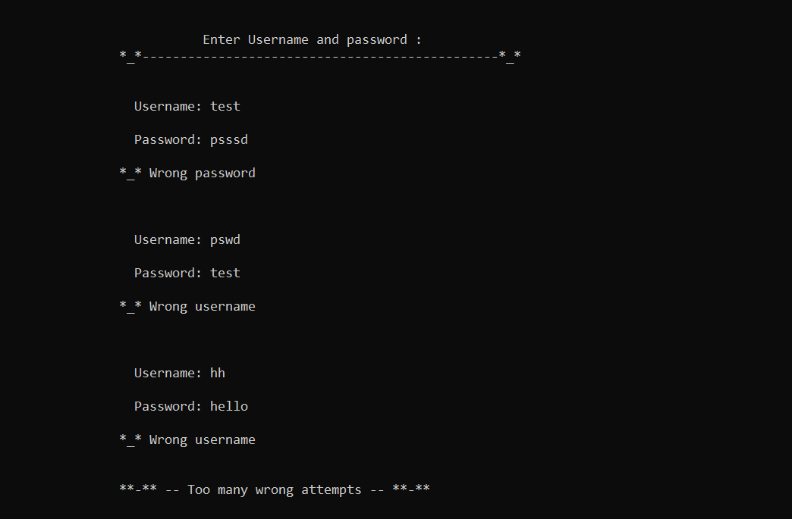

**4. Main Menu (mainmenu()):**

/* MAIN MENU */

void mainmenu(void)

{

system("cls");

char ar_nm[30], bk_nm[30];

int i, j;

i = j = 0;

while (j != 6)

{

system("cls");

printf("\n\n\n\t\t\t\t MAIN MENU ");

printf("\n\t\t*|*-------------------------------------------*|*");

printf("\n\n\n\t\t1. Add book information \n");

printf("\t\t2. Display Books information \n");

printf("\t\t3. Search a Book \n");

printf("\t\t4. List the title of books\n");

printf("\t\t5. Number of books in the library\n");

printf("\t\t6. Delete book information\n");

printf("\t\t7. Exit");

printf("\n\n\n\t\tEnter one of the above : ");

scanf("%d", &j);

if (j > 7)

{

printf("\n\t\tPlease Enter a valid option");

getch();

mainmenu();

}

switch (j)

{

/* Add book */

case 1:

addbooks();

break;

/* Display books */

case 2:

displaybooks();

break;

/* Search Book */

case 3:

searchbook();

break;

/* List by title of books */

case 4:

listbooks();

break;

/* Number of books */

case 5:

totalbooks();

break;

/* Delete book infomation */

case 6:

deletebooks();

break;

/* End screen */

case 7:

endscreen();

}

}

}

OUTPUT:

Main Menu

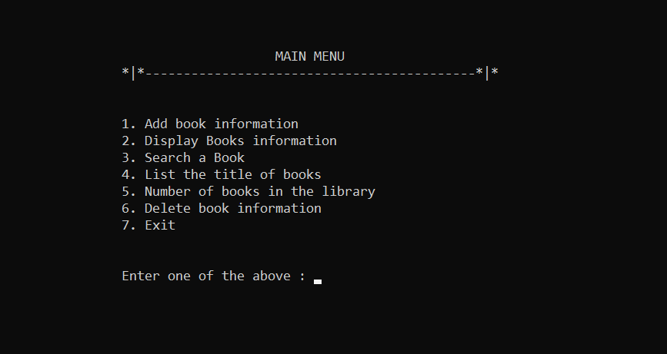

Error Control in main menu

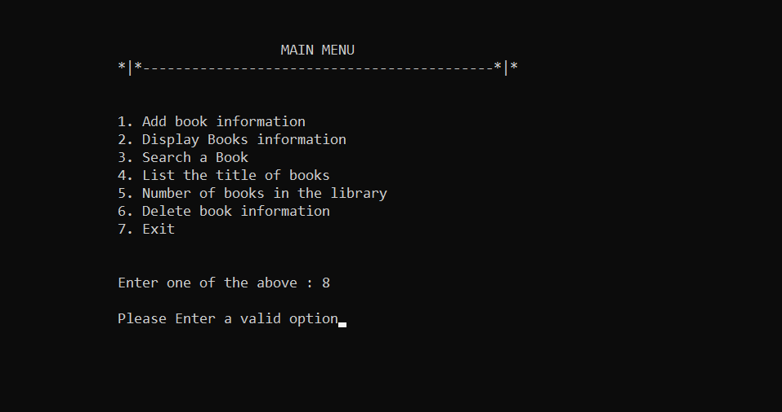

**5. Add books (addbooks()):**

/* Add book FUNCTION*/

void addbooks(void)

{

system("cls");

f1 = fopen("myfile1.txt", "a");

printf("\n\t\t Enter book information below: ");

printf("\n\t *_* -------------------------------------- *_*\n\n");

fflush(stdin);

printf("\t\tEnter book id : ");

scanf("%d", &li.bk_id);

fflush(stdin);

printf("\t\tEnter book name : ");

gets(li.bk_name);

fflush(stdin);

printf("\t\tEnter author name : ");

gets(li.author);

fflush(stdin);

printf("\t\tEnter pages : ");

scanf("%d", &li.pages);

fflush(stdin);

printf("\t\tEnter price : ");

scanf("%f", &li.price);

fwrite(&li, sizeof(li), 1, f1);

fclose(f1);

printf("\n\t **-** BOOK SUCCESSFULLY ADDED **-**");

printf("\n\n\t *_* Enter any key to go back to main menu...");

getch();

}

OUTPUT:

Add Book

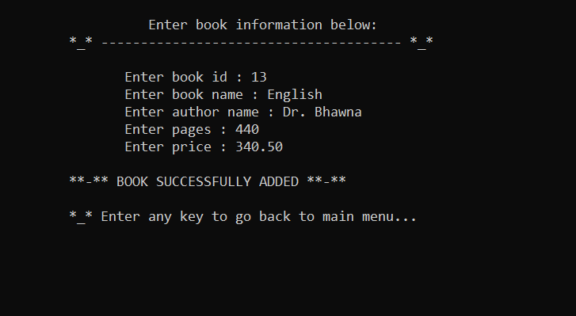

**6.Display Books (displaybooks()):**

/* Display books FUNCTION */

void displaybooks(void)

{

system("cls");

fr = fopen("myfile1.txt", "r");

printf("\n\t\t Books available in the library\n");

printf("\n\t **-** --------------------------------------- **-**\n\n");

while (fread(&li, sizeof(li), 1, fr) > 0)

{

printf("\n\t\t Book Id : %.2d", li.bk_id);

printf("\n\t\t Book Name : %s", li.bk_name);

printf("\n\t\t Author Name : %s", li.author);

printf("\n\t\t Number of pages : %d", li.pages);

printf("\n\t\t Price of book : %.2f", li.price);

printf("\n");

}

fclose(fr);

printf("\n\n\t *_* Enter any key to go back to main menu...");

getch();

}

OUTPUT:

Display Books

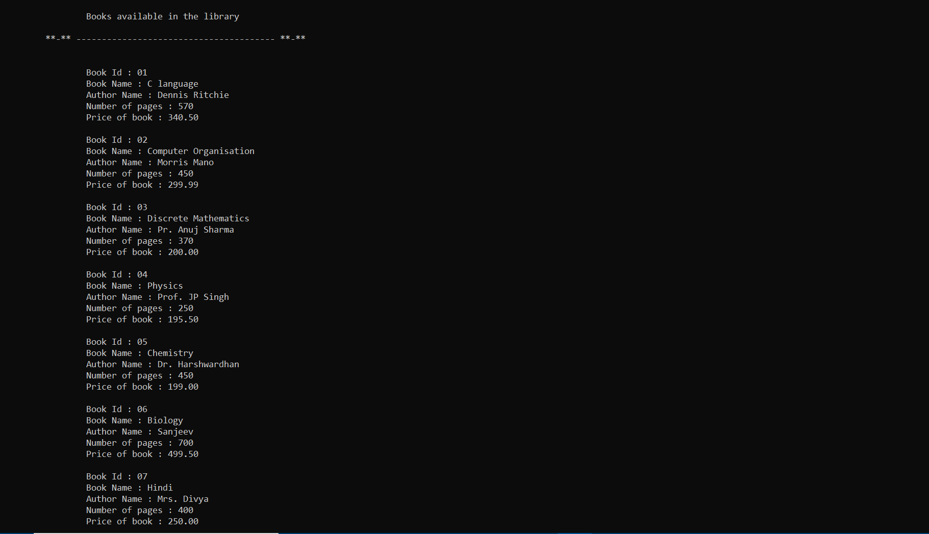

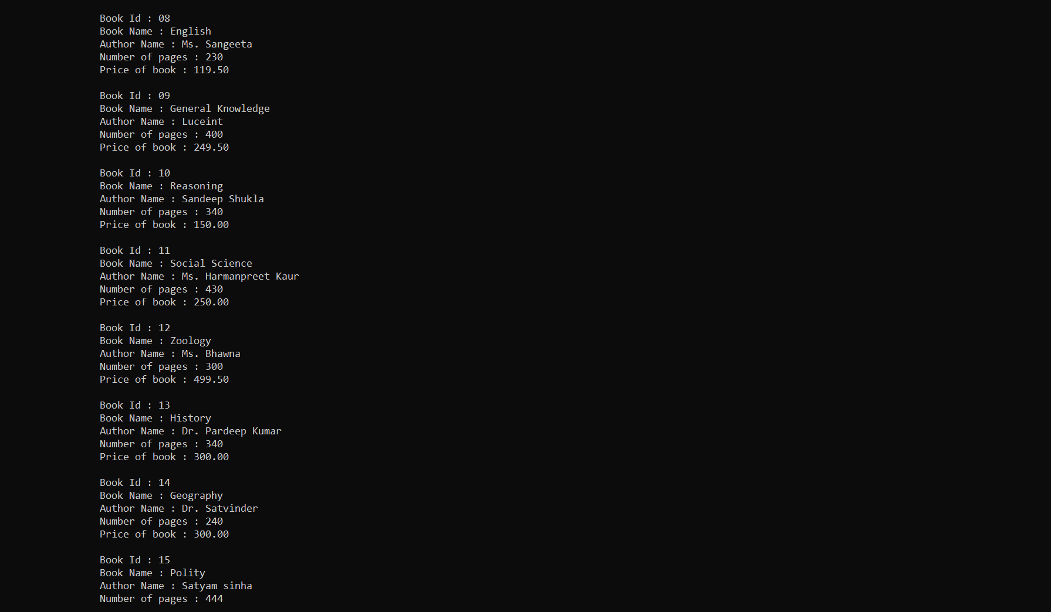

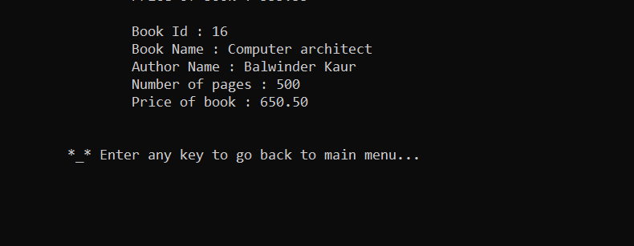

**7. Search book (searchbook()):**

/* Search Book FUNCTION*/

void searchbook(void)

{

int b_id, choice, found = 0;

char Bookname[20];

system("cls");

printf("\n\n\n\n\t\t\t Search a book : ");

printf("\n\t *_* ------------------------------------------ *_*\n\n");

printf("\n\t\t *-* Search By BookID : Type 1\n");

printf("\n\t\t *-* Search By BookName : Type 2");

printf("\n\n\t *_* ------------------------------------------ *_*\n");

fflush(stdin);

printf("\n\n\t\tEnter Your Choice : ");

scanf("%d", &choice);

switch (choice)

{

case 1:

printf("\n\n\t\t**-** Enter Book Id you want to search : ");

scanf("%d", &b_id);

fflush(stdin);

printf("\t *-*....................................................*-*\n");

fr = fopen("myfile1.txt", "r");

while (fread(&li, sizeof(li), 1, fr) > 0)

{

if (li.bk_id == b_id)

{

printf("\n\t\tBook Id : %.2d", li.bk_id);

printf("\n\t\tBook Name : %s", li.bk_name);

printf("\n\t\tAuthor Name : %s", li.author);

printf("\n\t\tNumber of Pages : %d", li.pages);

printf("\n\t\tPrice of Book : %.2f", li.price);

printf("\n\n\n\t **-** Enter any key to get back to main menu...");

getch();

mainmenu();

found = 1;

}

}

if (found == 0)

{

printf("\n\n\t\t *-* Book is Not Present in Library for Book ID : %d ", b_id);

printf("\n\n\n\t **-** Enter any key to get back to main menu...");

getch();

mainmenu();

}

fclose(fr);

break;

case 2:

fflush(stdin);

printf("\n\n\t\t *-* Enter Book Name you want to search : ");

gets(Bookname);

printf("\t *-*.....................................................*-*\n");

fr = fopen("myfile1.txt", "r+");

while (fread(&li, sizeof(li), 1, fr) > 0)

{

if (strcmp(Bookname, li.bk_name) == 0)

{

printf("\n\t\tBook Id : %.2d", li.bk_id);

printf("\n\t\tBook Name : %s", li.bk_name);

printf("\n\t\tAuthor Name : %s", li.author);

printf("\n\t\tNumber of Pages : %d", li.pages);

printf("\n\t\tPrice of Book : %.2f", li.price);

printf("\n\n\n\t **-** Enter any key to get back to main menu...");

getch();

mainmenu();

found = 1;

}

}

if (found == 0)

{

printf("\n\n\t\t *-* Book is Not Present in Library for Book name : %s ", Bookname);

printf("\n\n\n\t **-** Enter any key to get back to main menu...");

getch();

mainmenu();

}

fclose(fr);

break;

}

if (choice != 1 && choice != 2)

{

printf("\n\n\n\t **-** Please Enter a valid option...");

getch();

searchbook();

}

getch();

}

OUTPUT:

Search Book By Id

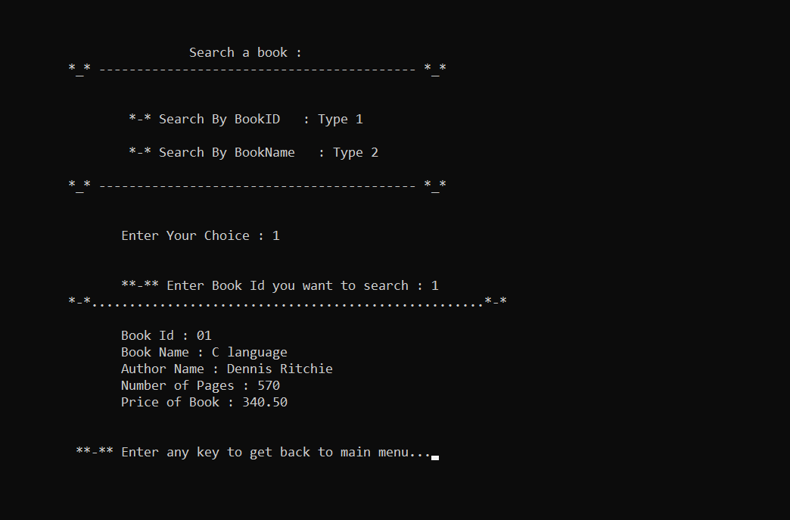

Search Book by Book Name

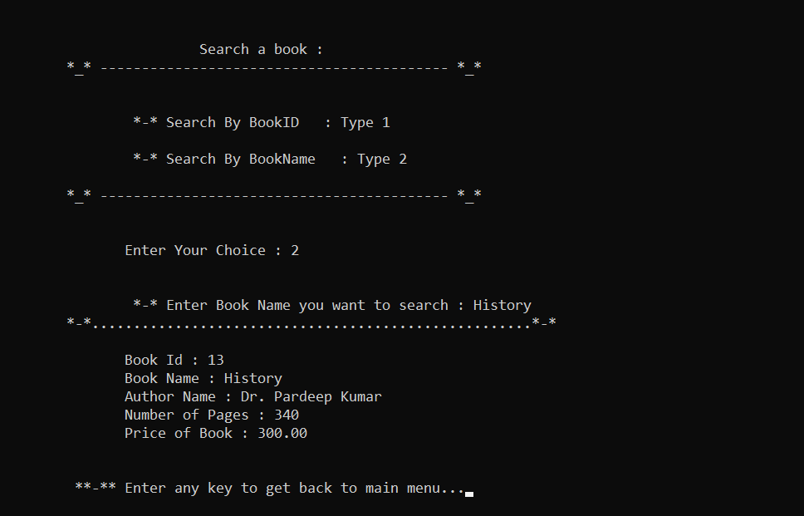

If the book is not present in Library it will print error message-

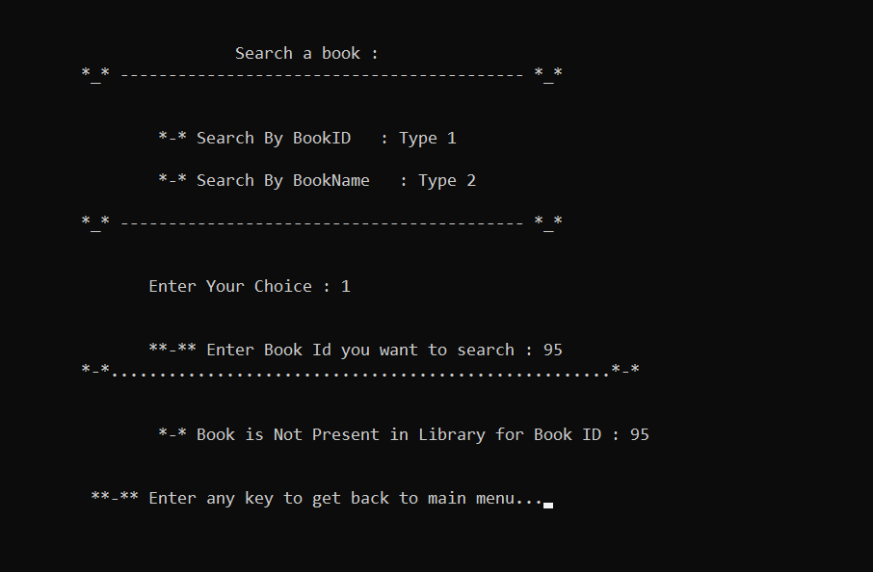

**8. List Books by Title (listbooks()):**

/* List by title of books FUNCTION */

void listbooks(void)

{

fflush(stdin);

system("cls");

printf("\n\n\n\n\t\t\t *_* Listed books according to the title ");

printf("\n\t *_* -------------------------------------------------------------- *_*\n\n\n");

fr = fopen("myfile1.txt", "r");

int i = 1;

while (fread(&li, sizeof(li), 1, fr) > 0)

{

printf("\n\t\t %.2d. Book Title : %s", i, li.bk_name);

i++;

}

printf("\n\n\n\t **-** Enter any key to get back to main menu...");

if (i = 0)

{

printf("\n\n\t\t *-* No Book is available in the library ");

printf("\n\n\n\t **-** Enter any key to get back to main menu...");

getch();

}

fclose(fr);

getch();

}

OUTPUT:

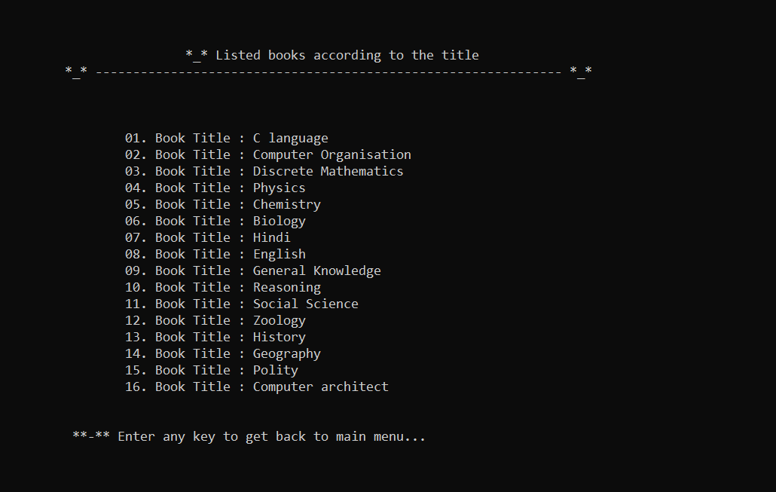

**9. Total Books (totalbooks()):**

/* Number of books FUNCTION */

void totalbooks(void)

{

int num = 0;

fr = fopen("myfile1.txt", "r");

while (fread(&li, sizeof(li), 1, fr) > 0)

{

num++;

}

fclose(fr);

if (num > 0)

{

printf("\n\t *_* ---------------------------------------------- *_*\n");

printf("\n\t\t Total number of books in library : %d", num);

printf("\n\n\t *_* ---------------------------------------------- *_*");

printf("\n\n\n\t **-** Enter any key to get back to main menu...");

getch();

}else

{

printf("\n\n\t\t *-* No Book is available in the library ");

printf("\n\n\n\t **-** Enter any key to get back to main menu...");

getch();

}

}

OUTPUT:

Total Number of books:

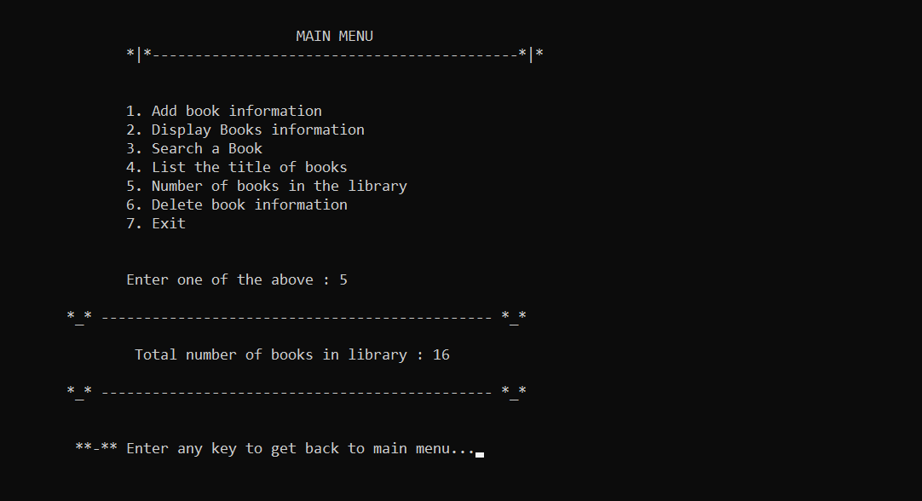

**10. Delete Books (deletebooks()):**

/* Delete books function */

void deletebooks(void)

{

int b_id, found = 0;

system("cls");

printf("\n\n\n\n\t\t\t Delete a book : ");

printf("\n\t *_* ------------------------------------------ *_*\n\n");

printf("\n\n\t\tEnter Book Id you want to Delete : ");

scanf("%d", &b_id);

fr = fopen("myfile1.txt", "r");

while (fread(&li, sizeof(li), 1, fr) > 0)

{

if (li.bk_id == b_id)

{

found = 1;

printf("\n\t\tBook Id : %d", li.bk_id);

printf("\n\t\tBook Name : %s", li.bk_name);

printf("\n\t\tAuthor Name : %s", li.author);

printf("\n\t\tNumber of Pages : %d", li.pages);

printf("\n\t\tPrice of Book : %.2f", li.price);

char yn;

printf("\n\n\t\tAre you sure You want to delete this book ");

fflush(stdin);

printf("\n\t\tEnter 'y' character to confirm you want to delete the book : ");

scanf("%c",&yn);

if(yn=='y'){

fflush(stdin);

continue;

}else{

fflush(stdin);

fclose(fr);

printf("\n\n\t *-* Book has not been deleted");

printf("\n\n\t *-* Enter any key to return to main menu...");

getch();

mainmenu();

}

}

}

if (found == 0)

{

printf("\n\n\t\t *_* Book Record Not Found");

printf("\n\n\t *_* ------------------------------------------ *_*");

printf("\n\n\n\t *-* Enter any key to go back to main menu ...");

getch();

system("cls");

fflush(stdin);

mainmenu();

}

rewind(fr);

fd = fopen("testfile1.txt", "w");

while (fread(&li, sizeof(li), 1, fr) > 0)

{

if (li.bk_id != b_id)

fwrite(&li, sizeof(li), 1, fd);

}

fclose(fr);

fclose(fd);

remove("myfile1.txt");

rename("testfile1.txt", "myfile1.txt");

if (found == 1)

{

printf("\n\n\t\t*-* This Book has been Deleted");

printf("\n\n\t\t*-* Enter any key to go back to main menu...");

}

getch();

system("cls");

mainmenu();

}

OUTPUT:

Delete Book

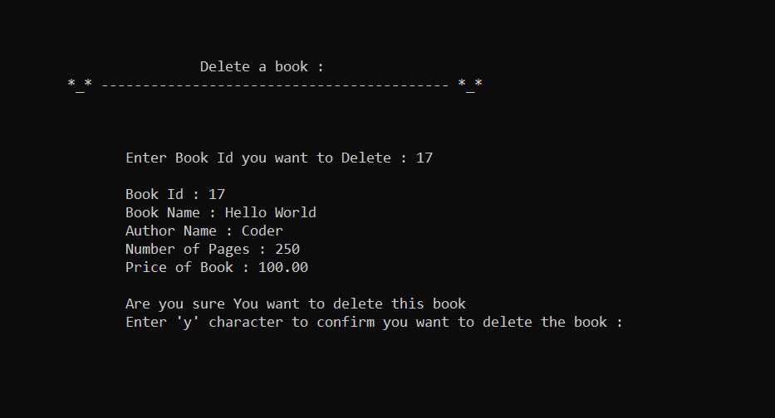

If Book Id is not present in library

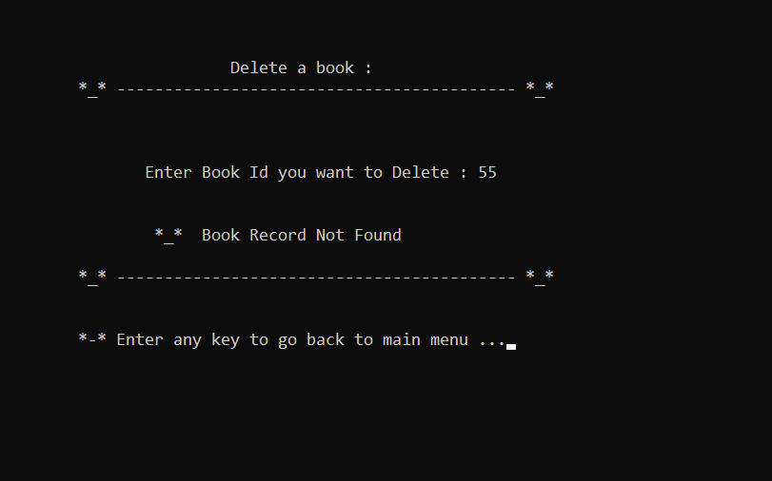

If conformation (i.e ‘y’ character is not pressed) is not given

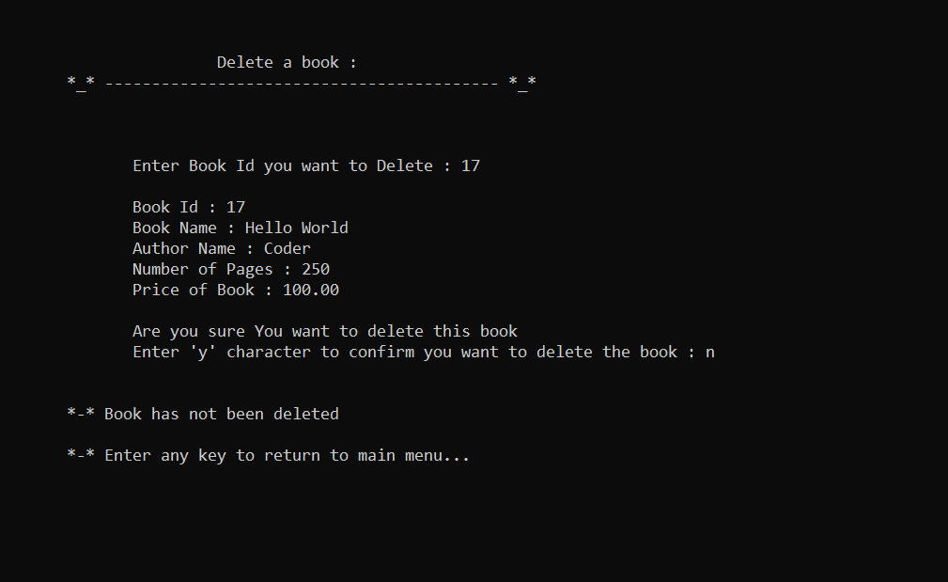

If conformation (i.e ‘y’ character is pressed) is given

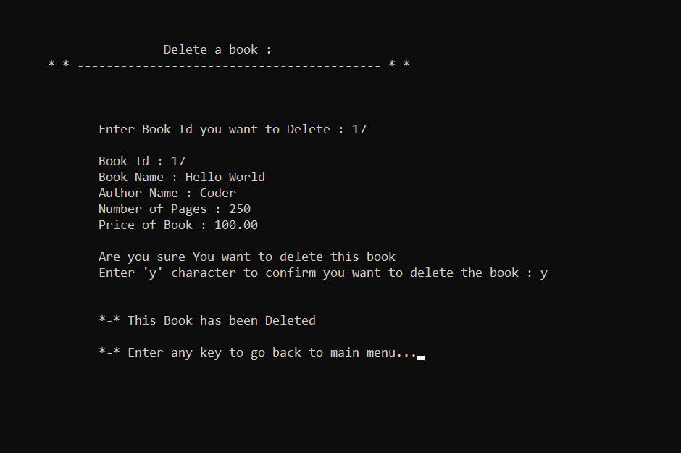

**9. Exit (endscreen()):**

/* End screen FUNCTION */

void endscreen(void)

{

system("cls");

printf("\n\n\n\n\n");

printf("\n\t\t\t **-**-**-**-**-**-**-**-**-**-**-**-**-**-**-**-**-**-**\n");

printf("\n\t\t\t =-=-=-=-=-=-=-=-=-=-=-=-=-=-=-=-=-=-=-=-=-=-=");

printf("\n\t\t\t = =");

printf("\n\t\t\t = T H A N K Y O U =");

printf("\n\t\t\t = =");

printf("\n\t\t\t = H A V E A N I C E D A Y =");

printf("\n\t\t\t = =");

printf("\n\t\t\t =-=-=-=-=-=-=-=-=-=-=-=-=-=-=-=-=-=-=-=-=-=-=\n");

printf("\n\t\t\t **_*_*_*_*_*_*_*_*_*_*_*_*_*_*_*_*_*_*_*_*_*_*_*_*_*_*_*_**\n");

printf("\n\n\n\n\n\n\n\n\n\n");

exit(0);

}

OUTPUT:

End Screen

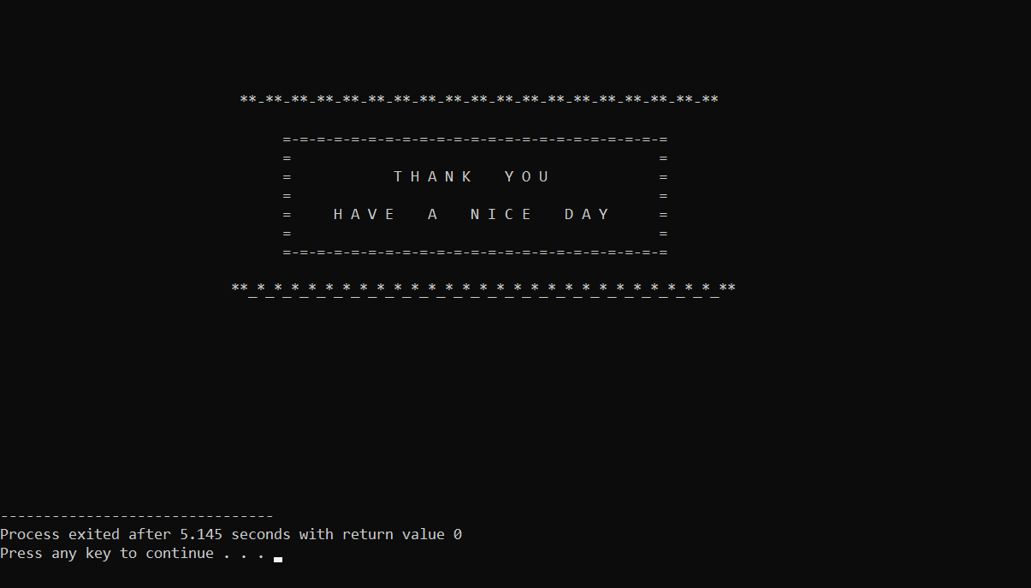

4. Testing

All function are working properly as we wanted.

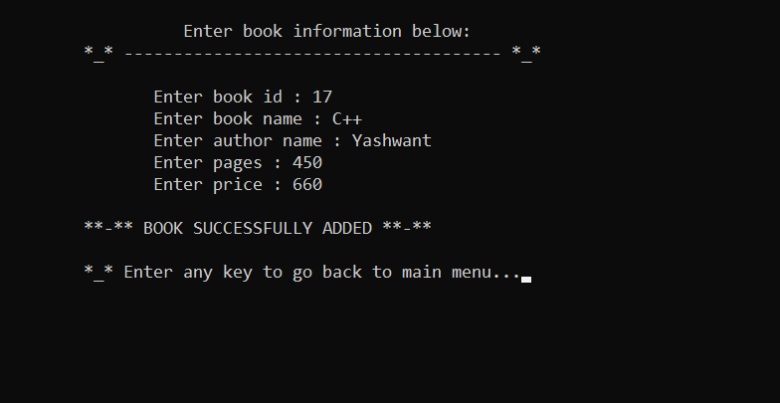

Output of myfile1.txt file

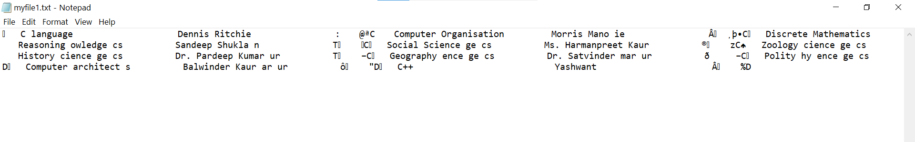

Display of books is also working fine

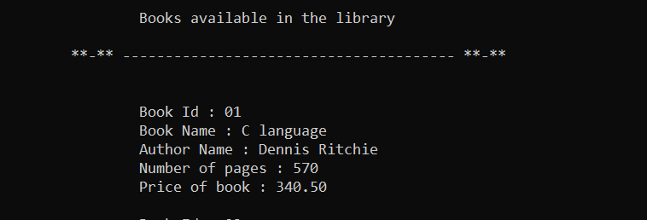

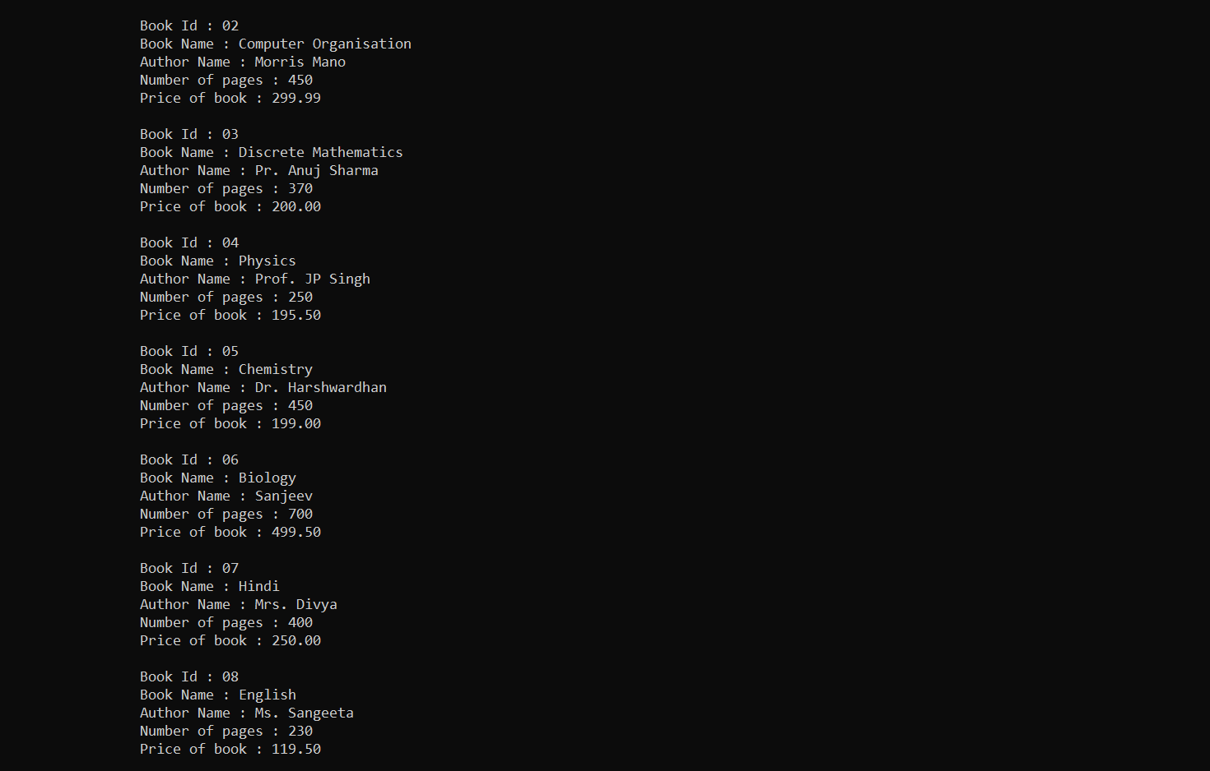

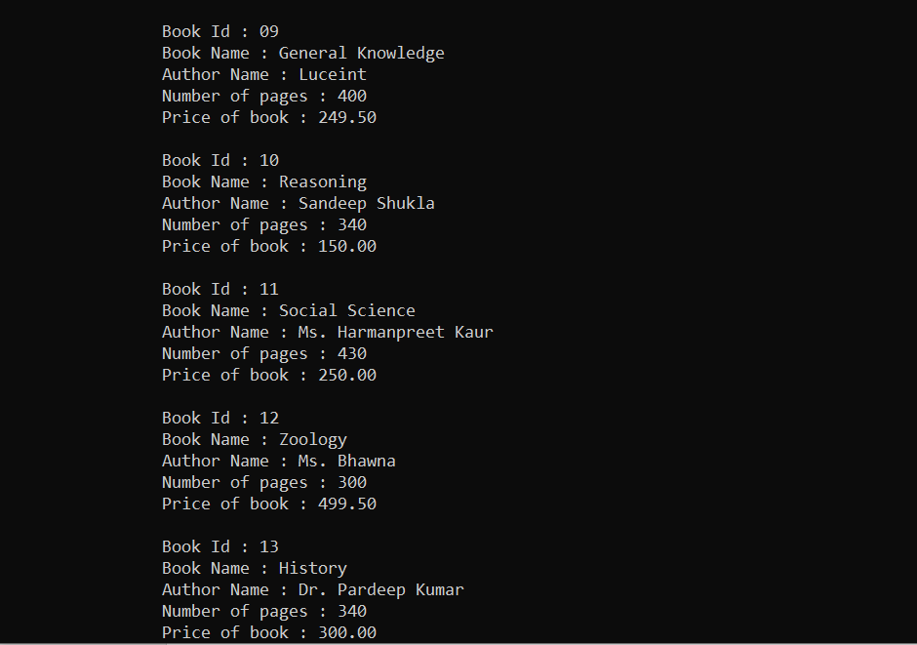

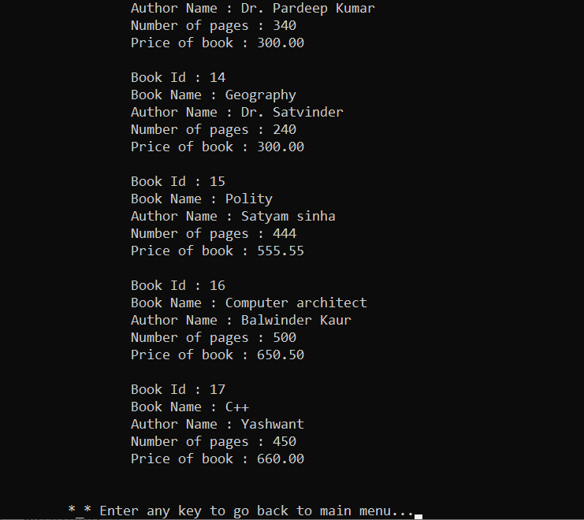

5. Conclusion

1. This The library Management System has been computed successfully and was also tested successfully by taking "test cases". It is user friendly, and has required options, which can be utilized by the user to perform the desired operations.
2. The software is developed using C language as front end and uses file handling as back end in Windows environment.
3. Optimum utilization of resources.
4. Efficient management of records.
5. Simplification of the operations.
6. Less processing time and getting required information. User friendly.
7. Portable and flexible for further enhancement.

Future Scope

1.Multiple books can be added at a time.

2.This is also used for students for issuing and returning books.

3.We can add date and time to check when the book is added in library and when the book is issued or returned to the student.

6. References

*Let Us C*

Yashavant Kanetkar

BPB Publications

14th Edition

[www.geeksforgeeks.org/c-programming-language/](http://www.geeksforgeeks.org/c-programming-language/)

https://www.youtube.com/

[www.google.com](http://www.google.com)

Thank You!